|  |  |
| --- | --- |
| **Logo - Club Logo copy**  Breakfast Chatter  2016/2017 | C:\Users\arasmussen\Pictures\New folder\Rotary.png |

##### The Weekly Bulletin of Rotary Club of Kathmandu Mid-Town Celebrating 27 Years of Rotary

### August is Membership and New Club Development Month

# Weekly Meetings and Programmes:

|  |  |  |
| --- | --- | --- |
| **Date** | **Speaker** | **Program/Topics of Presentation** |
| 2 September | In-house Speaker **Rtn. Dr. Rup Khadka** | ‘Federal Fiscal System’.  From Dr. Khadka’s CV:  I am an expert in the development and implementation of tax policy, tax legislation, tax administration and inter-governmental fiscal relations. I have over 25 years of experience in VAT, income tax, excise duties, customs duties, property taxes, inter-governmental fiscal relation, tax laws, tax regulations, tax procedures, tax administration ( including merger of VAT and income tax administrations, establishment of large taxpayer office, design and implementation of functional structure), capacity building, and taxpayer education. I have published many articles in national/international journals and published several books. I have prepared many reports/papers, including Harvard University’s HIID/ITP Discussion Papers/Working Papers. I have delivered lectures on VAT at the Tribhuvan University Nepal, National Institute of Public Finance and Policy India, Harvard University USA and Slavanic University Tajikistan.  Dr. Khadka is a new member of the club. |
| 26 August | **Quentin Wodon**,  Lead Economist in the Education Global Practice at the World Bank | **Increasing the Impact of Rotary through Partnership, Innovation and Evaluation**.  If Rotary is to have a larger impact globally, it must rely on partnerships, innovation, and evaluation (and in some areas advocacy, as has been the case with polio). Partnerships help to implement larger projects and benefit from the expertise of organizations that are among the best in their field. Without innovation, the contribution of Rotary is a drop in the development assistance bucket. But if Rotary innovates, successful pilots can be scaled up by other organizations with deeper pockets, thereby achieving larger impact. Finally, evaluation is needed to demonstrate the impact of pilot projects. Innovation and evaluation are like twins: they work best in pairs. Together, partnerships, innovation, and evaluation are they to impact. |
| Club News | | |

|  |  |  |  |
| --- | --- | --- | --- |
| Guest Speaker Quentin Wodon presented ways to increase impact of Rotary through Partnership, Innovation and Evaluation. Discussing the declining number of Rotary members in the US, he talked about the need to collaborate with non-Rotary service oriented people. He also suggested that C:\Users\arasmussen\AppData\Local\Microsoft\Windows\INetCache\Content.Outlook\CBTFF60Q\IMG_1426.JPGRotary Clubs must find ways to use the skills of its members.  You can find his PowerPoints as part of the minutes  C:\Users\arasmussen\AppData\Local\Microsoft\Windows\INetCache\Content.Outlook\CBTFF60Q\IMG_1432.JPGC:\Users\arasmussen\AppData\Local\Microsoft\Windows\INetCache\Content.Outlook\CBTFF60Q\IMG_1429.JPGRtn. Rup Khadka presented the vote of thanks,  and President Shankar presented a token of appriciation to Quentin Wodon | | A representative of Interact District Council requested Rs 5,000 as sponsorship for an Interact project which was approved immediately  C:\Users\arasmussen\AppData\Local\Microsoft\Windows\INetCache\Content.Outlook\CBTFF60Q\IMG_1436.JPG  C:\Users\arasmussen\AppData\Local\Microsoft\Windows\INetCache\Content.Outlook\CBTFF60Q\IMG_1433.JPGTRF Chair Isa reported that while she was in California with her daughter she visited former Mid-Towner Larry Meek and his wife Pamela.  Their Rotary Club of Nevada City has almost very active 100 members and.  Larry remembers us fondly and sends his good wishes to all Mid-Towners. Isa her hand over the banner from Nevada City to President Shankar.  Isa also reported that she has recently been in touch with Dr Sanjeeb Sharma who is working on the Snakebite Prevention/Treatment Project.  He reports that the data collection is now complete and that they are in the process of writing up the report/paper – it should be ready before the end of the year. | Other News Visiting Rotarian Annalisa Winberg, US informed the meeting about ‘Arjuna’s Dilemma’ a fusion opera performance to be staged at Patan Museum.    Artists from USA, Europe and Nepal will perform Arjuna’s Dilemma at Patan Durbar Square from **September 3 to 11**(There will be no performance on**September 6 and 7**.)  “It is the first Opera to be performed in Nepal. It is based on the text of the Bhagavad Gita and also the poetry of Kabir. It is a very unique production, on a majestic scale.”  Cultural Study Group of Nepal is privileged to have been offered the opportunity to meet with the music director of the opera, Jonathan Khuner, before the performance on**September 5th at 17.30** in the museum cafe. The meeting will take an hour and there is room for TWENTY PEOPLE only. If many more than that are interested the opera is willing to repeat the arrangement later on during the run.  Tickets for the opera MUST be bought separately, and are available at Patan Museum Gift Shop, Siddhartha Art Gallery and the Shangri-La Hotel. You can also send a text for a reservation to[**9803047148**](tel:9803047148).  Member of our club is also very welcome to this special evening |
|  |  | | | |

|  |
| --- |
| Rotary Story of the Week |

|  |  |  |
| --- | --- | --- |
| SHELTERBOX AND ROTARY CLUBS TAKE ACTION FOLLOWING EARTHQUAKE IN ITALY A 6.2-magnitude earthquake struck central Italy early Wednesday, killing more than 240 people and trapping an unknown number beneath rubble. Tremors were felt as far away as Rome, 100 km (65 miles) southwest of the quake's epicenter.  International disaster relief agency and Rotary International project partner [ShelterBox](https://www.shelterbox.org/" \t "_blank) is sending a response team from its headquarters in the United Kingdom to the remote mountainous area of Italy where the destruction is most severe. The response team will arrive Friday, 26 August, to assess the area's needs.  Luca Della Volta, president of [ShelterBox Italia](http://www.shelterbox.it/" \t "_blank), the affiliate organization in Genoa, will accompany the response team. Della Volta is working with the Rotary Club of Rieti in District 2080, the club closest to the earthquake-affected sites, and will meet with officials of the Italian Civil Protection Department, fire department, and Red Cross to coordinate efforts.  If families and individuals made homeless by the disaster need emergency shelter, ShelterBox will send tents and other equipment from its locations in Italy and other sites across Europe. Della Volta says the most urgent need is for tents and relief supplies for the hospital of Rieti, where most of the patients from the destroyed hospital in Amatrice were taken. |  |  |
|  |  |  |

# Rotary International News

[World Polio Day toolkit available — start planning now](https://www.rotary.org/myrotary/en/news-media/world-polio-day-toolkit-available-%E2%80%94-start-planning-now)

A massive [#polio](https://www.facebook.com/hashtag/polio?source=feed_text&story_id=10155284285009552) vaccination campaign is underway in Afghanistan. Over 9.5 million children will receive the polio vaccine and also vitamin A to boost their immune system.

### CELEBRATE 100 YEARS OF DOING GOOD

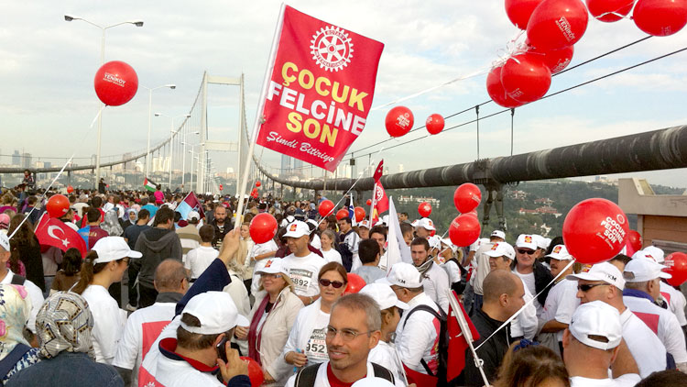

Explore The Rotary Foundation's history, watch our progress toward raising $300 million, and find ideas for planning your own centennial event.

[Visit centennial.rotary.org](http://centennial.rotary.org/)

### Rotary Calendar

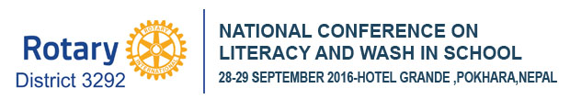

1 October — Deadline to submit nominations for the [Rotary Service Above Self Award](https://www.rotary.org/myrotary/en/learning-reference/learn-topic/awards)

24 October — [Rotary's World Polio Day Livestream Event](http://www.endpolio.org/worldpolioday)

31 October-6 November — World Interact Week

1 November — [Service Award for a Polio-Free World](https://www.rotary.org/myrotary/en/learning-reference/learn-topic/awards) nominations are due

### Please update your ‘My Rotary’ Account

First go to www.rotary.org.

Then **click on My Rotary**. And then **Click on Sign In/Register**.

If you are a first time user, click on **Create account.**

Fill in the Account registration information **and click on Continue.**

You will be informed that an e-mail has been sent to you.

Check your email for the address you provided in the step above. You will receive a message from Rotary. Click on the blue link in the mail to finalize the process.

# A Thought for the Day:

Sometimes life hits you in the head with a brick. I’m convinced that the only thing that kept me going was that I loved what I did. Your work is going to fill a large part of your life, and the only way to be truly satisfied is to do what you believe is great work. And the only way to do great work is to love what you do. Don’t settle [for less]. As with all matters of the heart, you’ll know when you find it.

\*\*\* Steve Jobs (1955 - 2011) \*\*\*

### Nepali holidays in August

|  |  |  |
| --- | --- | --- |
| 1 September is observed as Father's Day across the nation by showing respects and reverence to fathers by children. On this day, children feed their fathers delicious food items including sweets and show respect to them. Those who have lost their fathers take an early bath and visit nearby temples to perform shraddha (annual death rituals) in honour of the departed souls. Children also take blessings from their living fathers.  **Teej** is a generic name for a number of festivals that are celebrated in Nepal, Northern and Western India. Haryali Teej, Kajari Teej and Hartalika Teej welcome the monsoon season and are celebrated primarily by girls and women, with songs, dancing and prayer rituals.  The monsoon festivals of Teej are primarily dedicated to Goddess Parvati and her union with Lord Shiva and this year it is celebrated on Sunday September 4.  The festival is a three-day-long celebration that combines sumptuous feasts as well as rigid fasting. Teej is celebrated by women, for the long life of her husband and long and firm relationship between them in this life and all the lives to come.  The folk music and dances add more flavor to traditional values of Teej. Women in red dance and sing in the street, going to temple in holy and fasting mood. Teej is also called Haritalika Teej. This festival is celebrated by Nepali Hindu women all across the world.  Teej is a large red mite that comes out of the soil during the rainy season. It is said Teej got its name from the same mite. That is why Teej is celebrated in red. Source Wikipedia.  A meeting of the Constitution Day Main Celebrations Committee on Wednesday decided to observe the Day for three days from September 18 to 20 by organizing various programmes in Nepal and abroad. |  |  |
|  |  |  |

NB: Send any information/photos that may be of interest to the Club or Rotarians in general to

BC Editor: Anja M. Rasmussen, email: anjamrasmussen@gmail.com

District : 3292 Web: www.rotarymidtown.org.np Club Id : 26776

Facebook: <https://www.facebook.com/RotaryClubOfKathmanduMidtown>

Venue: Fridays at 7:30AM, Hotel de l'Annapurna, Kathmandu, NEPAL

Thanks to Isabell Khadka for a thought for today